**EECS 351 Project A Report**

**Goal**

Design and draw two different 3D parts which have two or more sequential, moving joints.

**User-guide**

Open the html file, there are one sequential rectangles, which models the posture of swimming, and a planet system, where three small balls spin around a big ball.

1. Press buttons on the web page to change the rotating speed or make the graphic stop.
2. Use mouse to drag the graphic to observe graphic with different view.
3. Stop the graphic quickly through press “Space” on the keyboard.

**Result**

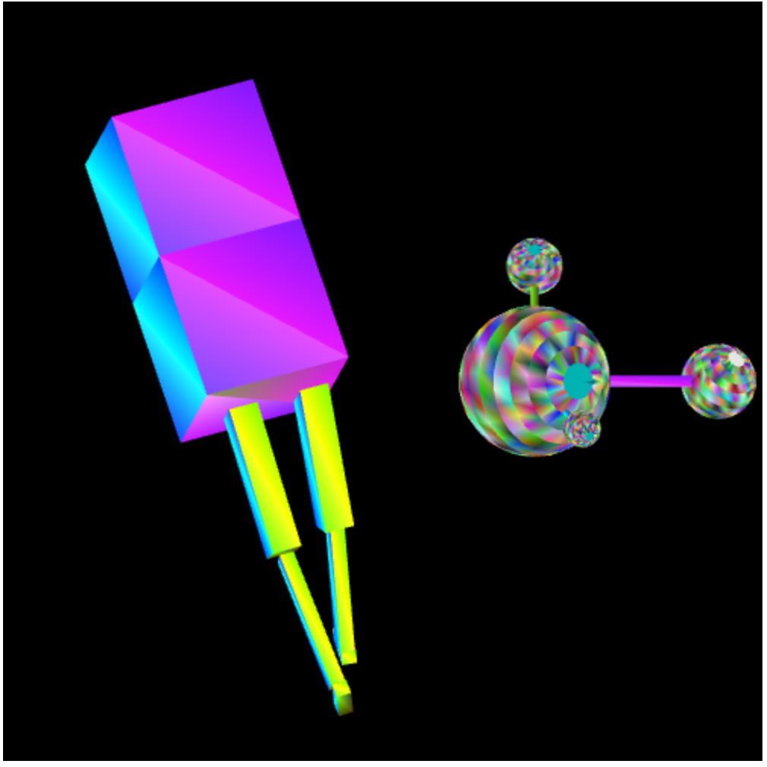

Figure 1

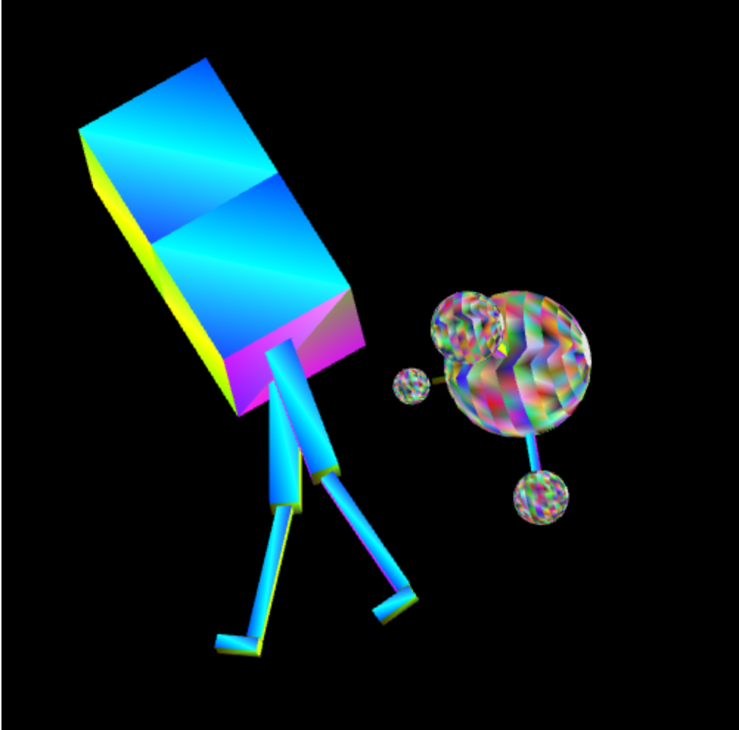

Figure 2

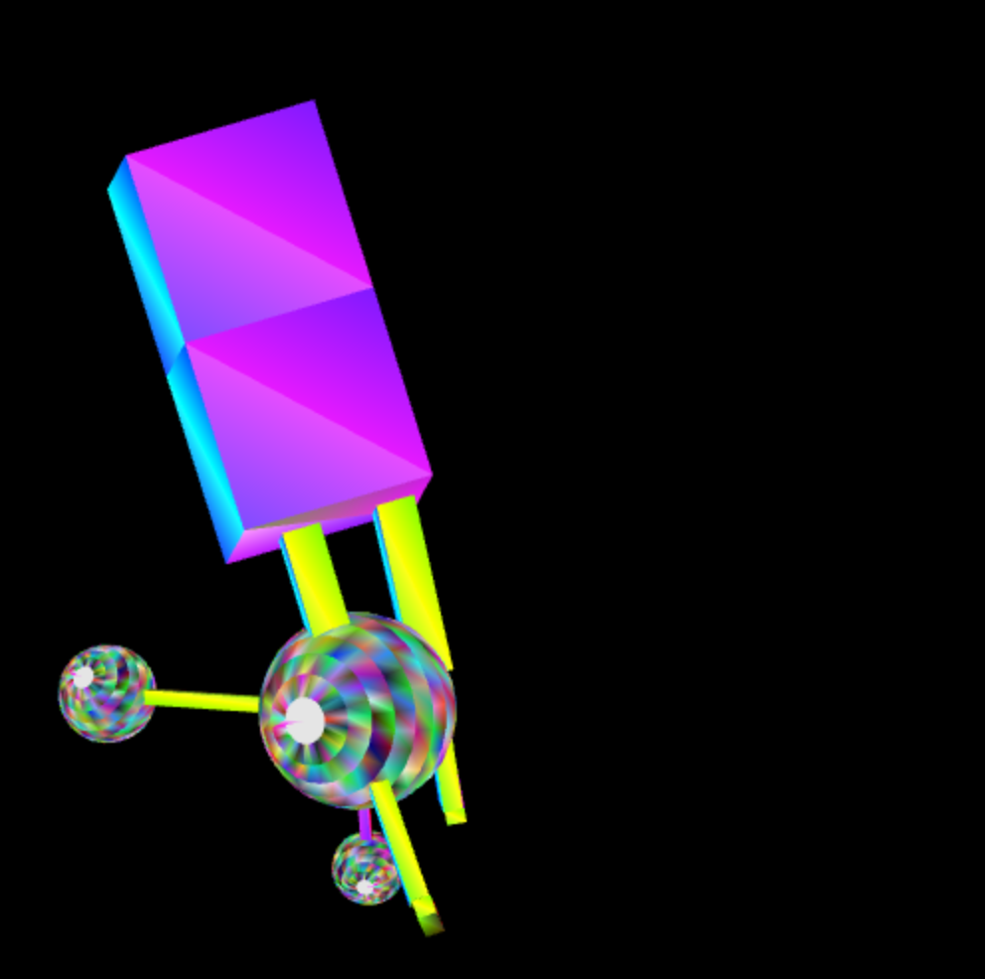

Figure 3

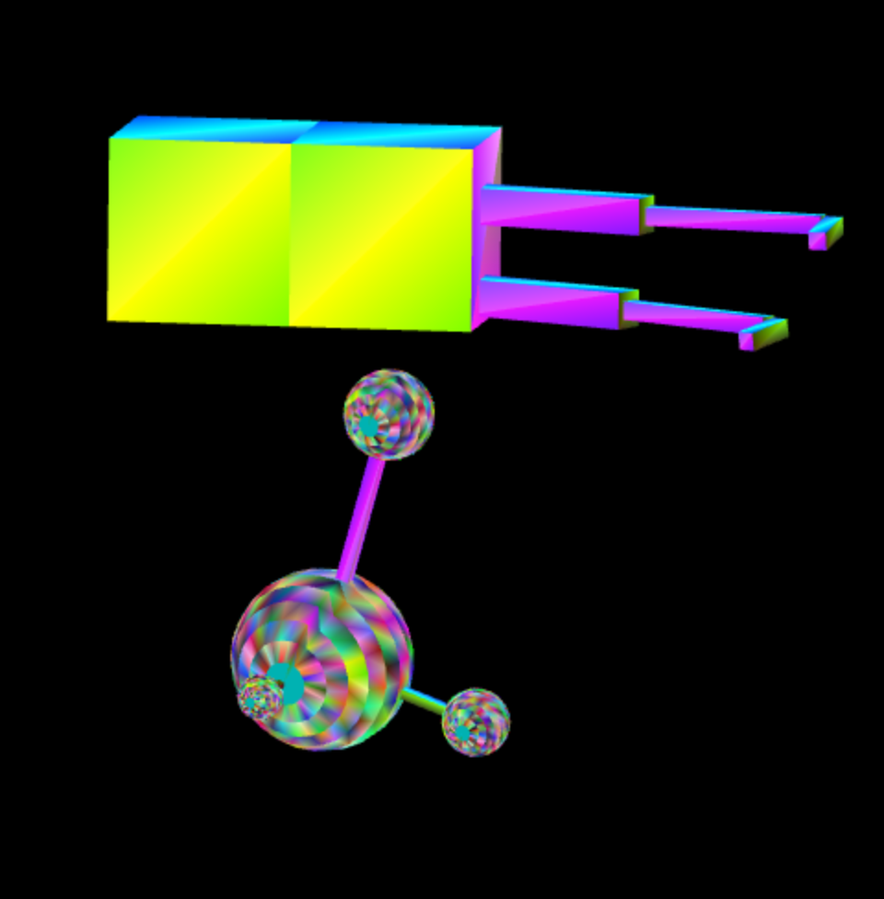

Figure 4

**Sketch of program’s scene-graph**

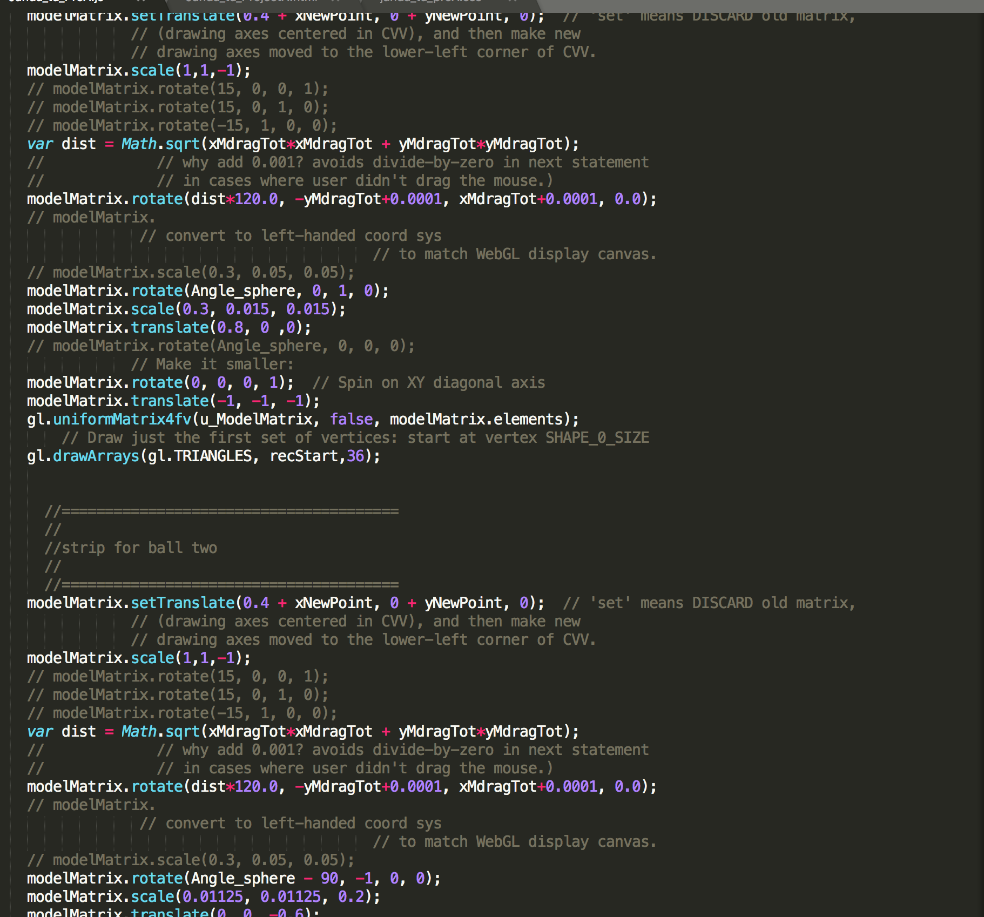

Figure 5